Average paid employment and average gross wages and salaries in the enterprise sector in April 2025
In April 2025, the average paid employment
in the enterprise sector was 6 446.8 thousand full-time equivalent employees, 0.8% lower than
a year earlier.
0.8%
YoY decrease in the average paid employment in the enterprise sector
The average monthly gross wage and salary
in the enterprise sector in April 2025 amounted to PLN 9 045.11, i.e. it increased nominally by 9.3% compared with April last year.
9.3%
YoY increase in the average monthly gross wage and salary in the enterprise sector

The presented data concern entities from the enterprise sector, which is part of the national economy.
Table 1. Average paid employment and average gross wages and salaries in the enterprise sector
In January 2025, the statutory minimum salary for work was raised to
PLN 4 666 i.e. by 8.5% compared with the last increase in July 2024, when it amounted to PLN 4 300, which also affected changes in average monthly gross wages and salaries in the enterprise sector
Specification | 04 2025 |  |  | 01-04 2025
Specification | in absolute numbers | 03 2025  =100 | 04 2024=  =100 | in absolute numbers | 01-04 2024=  =100
Average paid employment  in thousand full-time equivalent employees | 6 446.8 | 100.0 | 99.2 | 6 449.5 | 99.1
Total average gross wages and salaries in PLN | 9 045.11 | 99.9 | 109.3 | 8 827.46 | 108.5
of which excluding payments from profit | 9 044.65 | 99.9 | 109.3 | 8 827.32 | 108.5
In April 2025, the average paid employment in the enterprise sector remained at a similar level to March this year.

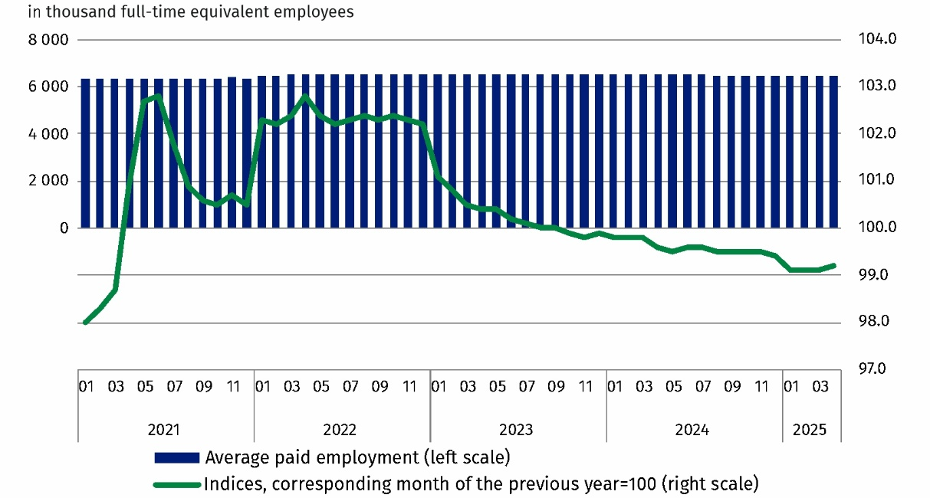
Chart 1. Average paid employment in the enterprise sector
In April 2025, the average monthly gross wage and salary in the enterprise sector decreased by 0.1% in nominal terms compared with the previous month.
Average monthly gross salary in the enterprise sector includes the base salary and additional salary components, including bonuses, awards, overtime pay and retirement severance pays

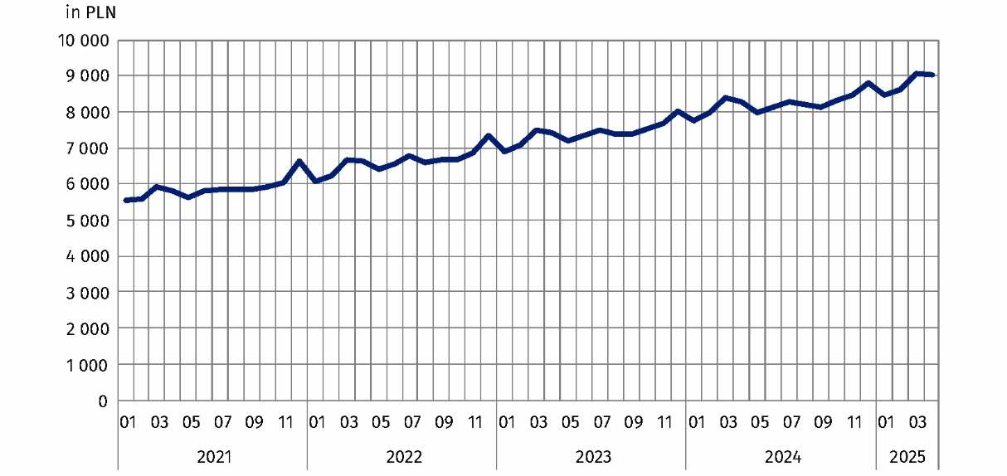
Chart 2. Average monthly gross wages and salaries in the enterprise sector

Methodological notes
The enterprise sector is part of the national economy and includes units with 10 or more employed persons, conducting business activities in the field of: forestry and logging; marine fishing; mining and quarrying; manufacturing; electricity, gas, steam and air conditioning supply; water supply; sewerage, waste management and remediation activities; construction; wholesale and retail trade; repair of motor vehicles and motorcycles; transportation and storage; accommodation and food service activities; information and communication; real estate activities; activities of head offices; management consultancy activities; architectural and engineering activities; technical testing and analysis; advertising and market research; other professional, scientific and technical activities; administrative and support service activities; arts, entertainment and recreation; repair of computers and personal and household goods; other personal service activities.
Data for the national economy are published quarterly, e.g. in the publication Paid employment, wages and salaries in the national economy.
Due to the short deadline for units to provide data as part of the survey with the use of DG-1 form, the results presented are preliminary. In the absence of complete records at the date of preparation of the report, it is permissible to report estimated data, and if data reported in previous periods need to be corrected, the changes are included only in the cumulative data.
In the case of quoting Statistics Poland data, please provide information: ‘Source of data: Statistics Poland’, and in the case of publishing calculations made on data published by Statistics Poland, please provide information: ‘Own work based on Statistics Poland data.’

Prepared by:  Statistical Office in Bydgoszcz  Director Wiesława Gierańczyk, Ph.D.  Phone: (+48 52) 366 93 90 | Issued by:  Press Office  Mobile phone: (+48) 695 255 032  Landline phones: +48 22 608 38 04, +48 22 449 41 45, +48 22 608 30 09  e-mail: obslugaprasowa@stat.gov.pl

stat.gov.pl/en/

@StatPoland

@GlownyUrzadStatystyczny

gus_stat

glownyurzadstatystycznygus

glownyurzadstatystyczny
Related information
Communications and Announcements
Statistical Bulletin No 3/2025
Socio-economic situation of the country
Seasonal adjustment – Average paid employment and average monthly gross wages and salaries
Paid employment, wages and salaries in the national economy in 2024
Methodological report. Statistics on labour market, wages and salaries
Data available in databases
Local Data Bank – Labour market
Macroeconomic Data Bank – Labour market
Knowledge Databases – labour market
Terms used in official statistics
Enterprise sector in the labour market and wages and salaries statistics
Average paid employment
Wages and salaries to calculate average monthly wages and salaries

Average paid employment after converting part-time employees into full-time equivalent employees.
See: Methodological notes.
Annex to the explanatory notes on reporting on paid employment, wages and salaries https://form.stat.gov.pl/formularze/2025/objasnienia/zalacznik_do_objasnien.pdf
More information: Methodological report. Monthly activity report of enterprises

