Average paid employment and average gross wages and salaries in the enterprise sector in July 2024
In July 2024, the average paid employment in the enterprise sector compared with July 2023 was lower by 0.4% and amounted to 6 488.8 thousand full-time equivalent employees.
0.4%
YoY decrease in the average paid employment in the enterprise sector
The average monthly wage and salary in the enterprise sector in July 2024 compared with July 2023 increased nominally by 10.6% and amounted to PLN 8 278.63 gross.
10.6%
YoY increase in the average monthly gross wage and salary in the enterprise sector

The presented data concern entities from the enterprise sector, which is part of the national economy.
Table 1. Average paid employment and average gross wages and salaries in the enterprise sector
In July 2024, the statutory minimum salary for work was raised to PLN 4 300 i.e. by 1.4% compared with the last increase in January 2024, when it amounted to PLN 4 242, which also affected changes in average monthly gross wages and salaries in the enterprise sector
Specification | 07 2024 |  |  | 01-07 2024
Specification | in absolute numbers | 06 2024  =100 | 07 2023=  =100 | in absolute numbers | 01-07 2023=  =100
Average paid employment  in thousand full-time equivalent employees | 6 488.8 | 100.1 | 99.6 | 6 510.1 | 99.6
Total average gross wages and salaries in PLN | 8 278.63 | 101.6 | 110.6 | 8 156.79 | 111.7
of which excluding payments from profit | 8 277.81 | 101.6 | 110.6 | 8 156.20 | 111.7
In July 2024, the average paid employment in the enterprise sector increased by 0.1% relative to June 2024.

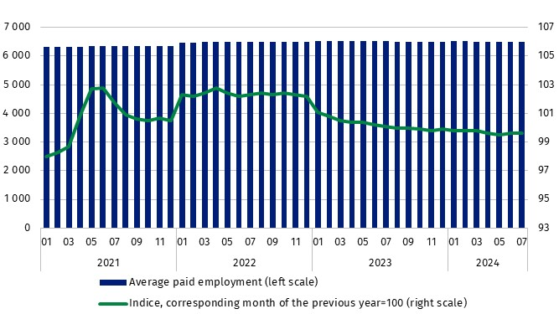
Chart 1. Average paid employment in the enterprise sector
In July 2024, the average monthly gross wage and salary in the enterprise sector increased nominally by 1.6% compared with June 2024. This increase was due to the payment of i.a. bonuses and awards, including incentive, quarterly and semi-annual ones, service anniversary awards, retirement severance pays (which, in addition to base salaries, are also included among the components of wages and salaries) as well as due to pay rises.
Average monthly gross wage or salary in the enterprise sector include the base salary and additional salary components, including bonuses, awards, overtime pay and retirement severance pays

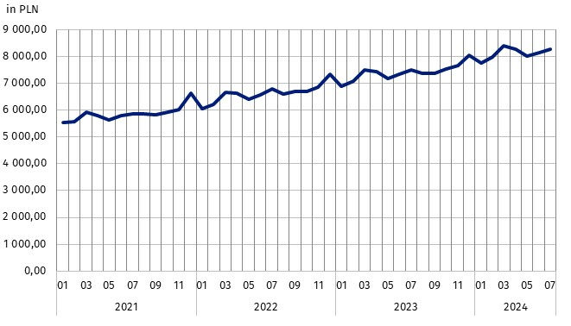
Chart 2. Average monthly gross wages and salaries in the enterprise sector

Methodological notes
The enterprise sector is part of the national economy and includes entities with 10 or more employed persons and conducting business activities. Data for the national economy are published quarterly, e.g. in the publication Paid employment, wages and salaries in the national economy.
In the case of quoting Statistics Poland data, please provide information: ‘Source of data: Statistics Poland’, and in the case of publishing calculations made on data published by Statistics Poland, please provide information: ‘Own work based on Statistics Poland data.’

Prepared by:  Statistical Office in Bydgoszcz  Director Wiesława Gierańczyk, Ph.D.  Phone: (+48 52) 366 93 90 | Issued by:  Press Office  Mobile phone: (+48) 695 255 032  Landline phones: +48 22 608 38 04, +48 22 449 41 45, +48 22 608 30 09  e-mail: obslugaprasowa@stat.gov.pl

stat.gov.pl/en/

@StatPoland

@GlownyUrzadStatystyczny

gus_stat

glownyurzadstatystycznygus

glownyurzadstatystyczny
Related information
Communications and Announcements
Statistical Bulletin No 6/2024
Socio-economic situation of the country in the first half of 2024
Seasonal adjustment – Average paid employment and average monthly gross wages and salaries
Paid employment, wages and salaries in the national economy in first quarter 2024
Methodological report Wages and salaries in the national economy
Data available in databases
Local Data Bank – Labour market
Macroeconomic Data Bank – Labour market
Terms used in official statistics
Enterprise sector in the labour market and wages and salaries statistics
Average paid employment
Wages and salaries to calculate average monthly wages and salaries

Average paid employment after converting part-time employees into full-time equivalent employees.
Annex to the explanatory notes on reporting on paid employment, wages and salaries http://form.stat.gov.pl/formularze/2024/objasnienia/zalacznik_do_objasnien.pdf
More information: Methodological report. Monthly activity report of enterprises

