Average paid employment and average gross wages and salaries in the enterprise sector in January 2024
In January 2024, the average paid employment in the enterprise sector compared with January 2023 was lower by 0.2% and amounted to 6 515.7 thousand full-time equivalent employees.
0.2%
YoY decrease in the average paid employment in the enterprise sector
The average monthly wage and salary in the enterprise sector in January 2024 compared with January 2023 increased nominally by 12.8% and amounted to PLN 7 768.35 gross.
12.8%
YoY increase in the average monthly gross wage and salary in the enterprise sector

The presented data concern entities from the enterprise sector, which is part of the national economy.
Table 1. Average paid employment and average gross wages and salaries in the enterprise sector
In January 2024, the statutory minimum salary for work was raised to PLN 4 242 i.e. by 17.8% compared with the last increase in July 2023, when it amounted to PLN 3 600, which also affected changes in average monthly gross wages and salaries in the enterprise sector
Specification | 01 2024
Specification | in absolute numbers | 12 2023=  =100 | 01 2023=  =100
Average paid employment  in thousand full-time equivalent employees | 6 515.7 | 100.3 | 99.8
Total average gross wages and salaries in PLN | 7 768.35 | 96.7 | 112.8
of which excluding payments from profit | 7 768.33 | 96.7 | 112.8
In January 2024, the average paid employment in the enterprise sector was 0.3% higher than in December 2023.

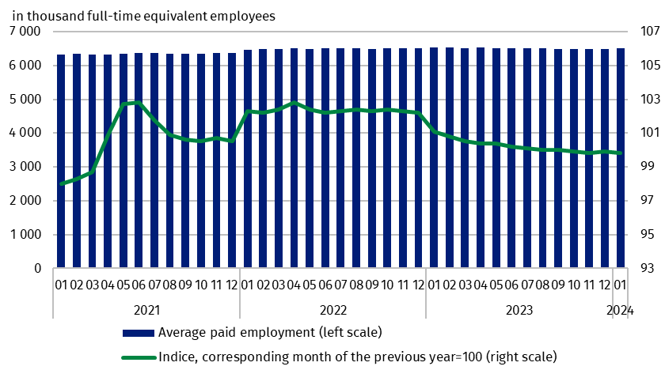
Chart 1. Average paid employment in the enterprise sector
Average monthly gross wage or salary in the enterprise sector include the base salary and additional salary components, including bonuses, awards, overtime pay and retirement severance pays
In January 2024, the average monthly gross wage and salary in the enterprise sector decreased nominally compared with December 2023 by 3.3%. This decrease was the result of a reduction in the scale or non-occurrence in January of payments that had taken place in the previous month, such as quarterly, annual and Christmas bonuses, annual awards, service anniversary awards, Miner’s Day awards, overtime pay, and retirement severance pays (which, in addition to base salaries, are also included among the components of wages and salaries).

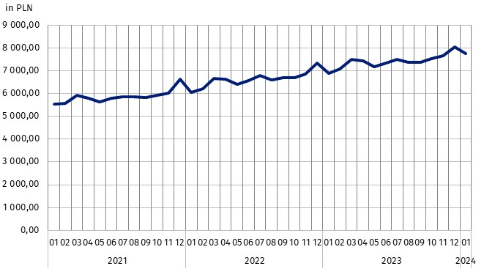
Chart 2. Average monthly gross wages and salaries in the enterprise sector

Methodological notes
The enterprise sector is part of the national economy and includes entities with 10 or more employed persons and conducting business activities. Data for the national economy are published quarterly, e.g. in the publication Paid employment, wages and salaries in the national economy.
As in previous years, the size class of the surveyed units was revised in January and a sample of medium-sized units (i.e. with 10 to 49 employed persons) was selected.
In the case of quoting Statistics Poland data, please provide information: ‘Source of data: Statistics Poland’, and in the case of publishing calculations made on data published by Statistics Poland, please provide information: ‘Own elaboration based on Statistics Poland data.’

Prepared by:  Statistical Office in Bydgoszcz  Director Wiesława Gierańczyk, Ph.D.  Phone: (+48 52) 366 93 90 | Issued by:  The Spokesperson for the President  of Statistics Poland  Karolina Banaszek  Phone: (+48) 695 255 011
Press Office  Phone: (+48 22) 608 38 04  e-mail: obslugaprasowa@stat.gov.pl |   stat.gov.pl/en/

@StatPoland

@GlownyUrzadStatystyczny

gus_stat

glownyurzadstatystycznygus

glownyurzadstatystyczny
Related information
Communications and Announcements
Statistical Bulletin No 12/2023
Socio-economic situation of the country in 2023
Seasonal adjustment - Average paid employment and average monthly gross wages and salaries
Paid employment, wages and salaries in the national economy in 1st-3rd quarters of 2023
Methodological report Wages and salaries in the national economy
Data available in databases
Local Data Bank – Labour market
Macroeconomic Data Bank – Labour market
Terms used in official statistics
Enterprise sector in the labour market and wages and salaries statistics
Average paid employment
Wages and salaries to calculate average monthly wages and salaries

Average paid employment after converting part-time employees into full-time equivalent employees.
Annex to the explanatory notes on reporting on paid employment, wages and salaries http://form.stat.gov.pl/formularze/2024/objasnienia/zalacznik_do_objasnien.pdf
More information: Methodological report. Monthly activity report of enterprises

