Average paid employment and average gross wages and salaries in the enterprise sector in November 2023
In November 2023, the average paid employment in the enterprise sector compared with November 2022 was lower by 0.2%
and amounted to 6 494.0 thousand full-time equivalent employees. Compared to the previous month, the average paid employment was recorded at a similar level.
11.8%
YoY increase in the average monthly gross wage and salary in the enterprise sector

0.2%
YoY decrease in the average paid employment in the enterprise sector
The average monthly wage and salary in the enterprise sector in November 2023 compared with November 2022 increased nominally
by 11.8% and amounted to PLN 7670.19 gross. Compared with October 2023, the average monthly gross wage and salary increased nominally by 1.7%.

Labour market in the enterprise sector
The enterprise sector is part of the national economy, which means that the data refer to selected entities conducting economic activity
The enterprise sector is part of the national economy, which means that data concern units conducting economic activity classified into selected kinds of activity according to NACE Rev. 2, with 10 or more employed persons. Therefore, the survey does not include, inter alia, public administration, education, human health and social work activities. Basic data on this sector are published monthly and for the national economy as a whole quarterly, e.g. in the statistical information Paid employment, wages and salaries in the national economy.
Table 1. Average paid employment and average gross wages and salaries in the enterprise sector
Specification | 11 2023 |  |  | 01-11 2023
Specification | in absolute numbers | 10 2023=  =100 | 11 2022=  =100 | in absolute numbers | 01-11 2022=  =100
Average paid employment  in thousand full-time equivalent employees | 6494.0 | 100.0 | 99.8 | 6522.2 | 100.4
Total average gross wages and salaries in PLN | 7670.19 | 101.7 | 111.8 | 7390.58 | 112.1
of which excluding payments from profit | 7670.12 | 101.7 | 111.8 | 7389.39 | 112.1
In November 2023, the average paid employment in the enterprise sector remained
at a similar level to that recorded in October 2023, similarly as in October 2023 compared with September 2023. Comparing November 2023 to November 2022, the average paid employment decreased by 0.2%.

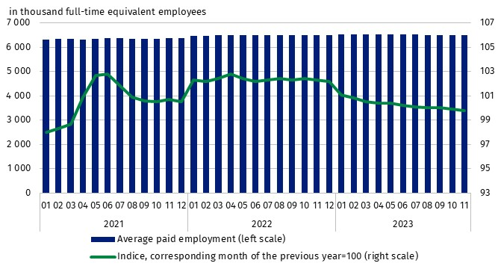
Chart 1. Average paid employment in the enterprise sector
Average monthly gross wages and salaries in the enterprise sector include the base salary and additional salary components, including bonuses, awards, overtime pay and retirement severance pays
In November 2023, the average monthly gross wage and salary in the enterprise sector increased nominally by 1.7% compared with October 2023. This increase was caused by, among others, payments of quarterly, incentive and discretionary bonuses, service anniversary awards, retirement severance pays (beside the base salary they are also included as components of wages and salaries)
The largest nominal increase in the average monthly gross wage and salary compared
to the previous month occurred in the Electricity, gas, steam and air conditioning supply∆ section (by 27,2%). The highest value of the average monthly wage and salary in November was recorded, similarly to the previous month, in Mining and quarrying section
(PLN 16 688.36), and the lowest in the Accommodation and catering∆ section (PLN 5 444.54).
On an annual basis (November 2023 to November 2022), the average monthly gross wage and salary increased nominally by 11.8%.

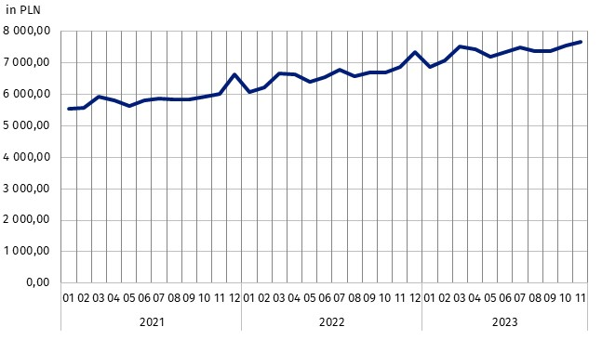
Chart 2. Average monthly gross wages and salaries in the enterprise sector
In July 2023, the statutory minimum salary was raised to PLN 3 600, i.e. by 19.6% compared with 2022, when
it amounted to PLN 3 010
(in 2022 an increase of 7.5% compared with 2021), which also affected changes in average monthly gross wages and salaries in the enterprise sector

Cumulatively, during the eleven months of 2023, the average monthly gross wage and salary in the enterprise sector compared to the same period in 2022 increased nominally by 12.1%. The increase occurred in all PKD/NACE sections, ranging from 7.3% in the Construction section to 17.9% in the Mining and quarrying section. The highest average monthly gross wage and salary in the enterprise sector in the cumulative period was recorded in the Information and communication section (PLN 12 484.30), and the lowest in the Accommodation and catering∆ section (PLN 5 349.07).

Methodological notes
The enterprise sector comprises units with 10 or more employed persons, conducting economic activity within the scope of the following areas: forestry and logging; marine fishing; mining and quarrying; manufacturing; electricity, gas, steam and air conditioning supply; water supply; sewerage, waste management and remediation activities; construction; wholesale and retail trade; repair of motor vehicles and motorcycles; transportation and storage; accommodation and food service activities; information and communication; real estate activities; legal and accounting activities; activities of head offices; management consultancy activities; architectural and engineering activities; technical testing and analysis; advertising and market research; other professional, scientific and technical activities; administrative and support service activities; arts, entertainment and recreation; repair of computers and personal and household goods; other personal service activities.
Data source is ‘Report on economic activity’ (DG-1). Within the scope of this survey, for the entities with 50 or more employed persons it is a census survey, while for the entities with 10 to 49 employed persons it is a sample survey.
Labour market data from the DG-1 survey report do not include people employed under a contract of mandate and a contract to perform a specified task – the detailed scope of exclusions along with methods of calculating labour market variables can be found in the explanations of the DG-1 report.
Due to the short time in which the units provide data as part of the survey on the DG-1 form, the presented results are preliminary. In the absence of complete records as at the date of preparation of the report, it is allowed to include estimated data, and in the event of the need to correct data reported in previous periods, changes are included only in cumulative data.
In this news release abbreviated names of NACE, Rev. 2 sections were used. Abbreviations are marked with a ‘Δ’ symbol. Full names are available on the Eurostat website at: https://ec.europa.eu/eurostat/data/classifications.
In the case of quoting Statistics Poland data, please provide information: ‘Source of data: Statistics Poland’, and in the case of publishing calculations made on data published by Statistics Poland, please provide information: ‘Own elaboration based on Statistics Poland data.’

Prepared by:  Statistical Office in Bydgoszcz  Director Wiesława Gierańczyk, Ph.D.  Phone: (+48 52) 366 93 90 | Issued by:  The Spokesperson for the President  of Statistics Poland  Karolina Banaszek  Phone: (+48) 695 255 011
Press Office  Phone: (+48 22) 608 38 04  e-mail: obslugaprasowa@stat.gov.pl |   stat.gov.pl/en/

@StatPoland

@GlownyUrzadStatystyczny

gus_stat

glownyurzadstatystycznygus

glownyurzadstatystyczny
Related information
Working. Employed. Wages and salaries. Cost of labour
Paid employment, wages and salaries in the national economy in the first half of 2023
Structure of wages and salaries by occupations in October 2020
Methodological report Employment in the national economy
Methodological report Wages and salaries in the national economy
Data available in databases
Local Data Bank – Labour market
Macroeconomic Data Bank – Labour market
Terms used in official statistics
Enterprise sector in the labour market and wages and salaries statistics
Average paid employment
Wages and salaries to calculate average monthly wages and salaries

Average paid employment after converting part-time employees into full-time equivalent employees.
Activities included in the enterprise sector are listed on the page 4.
Annex to the explanatory notes on reporting on paid employment, wages and salaries http://form.stat.gov.pl/formularze/2023/objasnienia/zalacznik_do_objasnien.pdf
Methodological report Monthly activity report of enterprises: https://stat.gov.pl/en/topics/economic-activities-finances/activity-of-enterprises-activity-of-companies/methodological-report-monthly-activity-report-of-enterprises,17,1.html
DG-1 report in English is available in Methodological report Monthly activity report of enterprises: https://stat.gov.pl/en/topics/economic-activities-finances/activity-of-enterprises-activity-of-companies/methodological-report-monthly-activity-report-of-enterprises,17,1.html

