Average paid employment and average gross wages and salaries in the enterprise sector in June 2023
In June 2023, the average paid employment in the enterprise sector compared with June 2022 was higher by 0.2% y/y and amounted to 6 512.8 thousand full-time equivalent employees. In comparison to the previous month the average paid employment slightly decreased by 0.1%.
0.2%
Increase y/y in the average paid employment in the enterprise sector
Average gross wages and salaries in the enterprise sector in June 2023 compared with June 2022 were higher by 11.9% y/y and amounted to PLN 7 335.20. Compared with May 2023 average gross wages and salaries increased by 2.1%.
11.9%
Increase y/y in the average gross wages and salaries in the enterprise sector

Labour market in the enterprise sector
The enterprise sector is part of the national economy, which means that the data refer to selected entities conducting economic activity

Data regarding the enterprise sector concern units conducting economic activity classified into selected kinds of activity according to NACE Rev.2, with 10 or more employed persons. Therefore, the survey does not include, inter alia, public administration, education, human health and social work activities.
Table 1. Average paid employment and average gross wages and salaries in the enterprise sector
Specification | 06 2023 |  |  | 01–06 2023
Specification | in absolute  numbers | 05 2023=  =100 | 06 2022=  =100 | in absolute numbers | 01–06 2022=  =100
Average paid employment  in thousand full-time equivalent employees | 6 512.8 | 99.9 | 100.2 | 6 523.2 | 100.7
Total average gross wages and salaries in PLN | 7 335.20 | 102.1 | 111.9 | 7 271.88 | 112.7
of which excluding payments from profit | 7 333.73 | 102.1 | 111.9 | 7 271.30 | 112.7

In June 2023, the average paid employment in the enterprise sector in comparison to May 2023 decreased by 0.1%. The slight decrease in the average paid employment in June 2023 was caused, i.a. by redundancies of employees in the units and the expiry of fixed-term contracts.
Comparing June 2023 to June 2022, the average paid employment in the enterprise sector increased by 0.2%. In June 2022 the recorded y/y increase was higher and amounted to 2.2%.

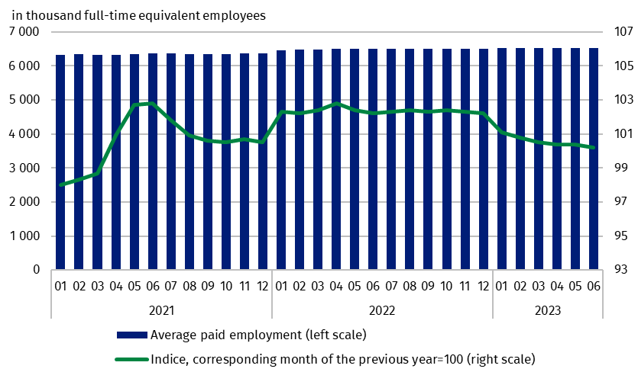
Chart 1. Average paid employment in the enterprise sector
In June 2023 the average monthly gross wage and salary in the enterprise sector increased compared with May 2023 by 2.1%. A year earlier, in June 2022, compared with May 2022, wages and salaries increased by 2.4%.
Average monthly gross wages and salaries in the enterprise sector include the base salary and additional salary components, including bonuses, awards, overtime pay and retirement severance pays

The increase in average monthly wages and salaries in June 2023, compared with May 2023 was caused by bigger scale of additional payments i.a. quarterly and annual bonuses, jubilee awards, and also retirement severance pays (which beside the base salary are also included as components of wages and salaries). The increase in wages and salaries was noted in almost all sections, of which the highest in section Mining and quarrying (by 10.7%), where salaries increase to PLN 11 290.69 (a month earlier amounted to PLN 10 201.34) and Electricity, gas, steam and air conditioning supply (by 7.4%), where salaries increased to PLN 10 063.21 (a month earlier were PLN 9 365.97).
On an annual basis (June 2023 to June 2022), the average monthly gross wage and salary increased by 11.9%. A year earlier (June 2022 to June 2021) the dynamics of growth in the average wage and salary was recorded at the level of 13.0%.

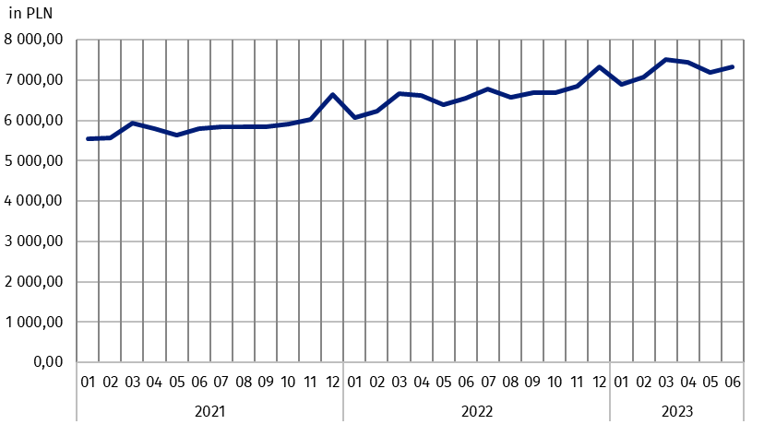
Chart 2. Average monthly gross wages and salaries in the enterprise sector
In January 2023, the statutory minimum salary increased to PLN 3 490, i.e. by 15.9% compared with 2022, when it amounted to PLN 3 010 (in 2022 an increase of 7.5% compared with 2021), which also affected changes in average monthly gross wages and salaries in the enterprise sector
In the cumulative period of six months of 2023, average monthly gross wages and salaries in the enterprise sector, in relation to the same period of 2022 increased in all NACE Rev.2 sections by between 7.5% in section Construction and 18.3% in section Transportation and storage, which resulted in a total increase in the enterprise sector of 12.7%. The highest average gross wage and salary in the enterprise sector in the cumulative period was recorded in section Information and communication in the amount of PLN 12 551.29 (an increase of 12.6% compared with the same period of the previous year), while the lowest in section Accommodation and food service activities at the level of PLN 5 262.29 (despite an increase in relation to the situation a year ago by 14.0%).

Methodological notes
The enterprise sector comprises units with 10 or more employed persons, conducting economic activity within the scope of the following areas: forestry and logging; marine fishing; mining and quarrying; manufacturing; electricity, gas, steam and air conditioning supply; water supply; sewerage, waste management and remediation activities; construction; wholesale and retail trade; repair of motor vehicles and motorcycles; transportation and storage; accommodation and food service activities; information and communication; real estate activities; legal and accounting activities; activities of head offices; management consultancy activities; architectural and engineering activities; technical testing and analysis; advertising and market research; other professional, scientific and technical activities; administrative and support service activities; arts, entertainment and recreation; repair of computers and personal and household goods; other personal service activities.
Data source is ‘Report on economic activity’ (DG-1). Within the scope of this survey, for the entities with 50 or more employed persons it is a census survey, while for the entities with 10 to 49 employed persons it is a sample survey.
Labour market data from the DG-1 survey report do not include people employed under a contract of mandate and a contract to perform a specified task – the detailed scope of exclusions along with methods of calculating labour market variables can be found in the explanations of the DG-1 report.
Due to the short time in which the units provide data as part of the survey on the DG-1 form, the presented results are preliminary. In the absence of complete records as at the date of preparation of the report, it is allowed to include estimated data, and in the event of the need to correct data reported in previous periods, changes are included only in cumulative data.

Full names are available on the Eurostat website at: https://ec.europa.eu/eurostat/data/classifications. In this news release abbreviated names of NACE, Rev. 2 sections were used. Abbreviations are marked with a ‘Δ’ symbol.

In the case of quoting Statistics Poland data, please provide information: ‘Source of data: Statistics Poland’, and in the case of publishing calculations made on data published by Statistics Poland, please provide information: ‘Own elaboration based on Statistics Poland data.’
Prepared by:  Statistical Office in Bydgoszcz  Director Wiesława Gierańczyk, Ph.D.  Phone: (+48 52) 366 93 90 | Issued by:  The Spokesperson for the President  of Statistics Poland  Karolina Banaszek  Phone: (+48) 695 255 011
Press Office  Phone: (+48 22) 608 38 04  e-mail: obslugaprasowa@stat.gov.pl |   stat.gov.pl/en/

@StatPoland

@GlownyUrzadStatystyczny

gus_stat

glownyurzadstatystycznygus

glownyurzadstatystyczny
Related information
Working. Employed. Wages and salaries. Cost of labour
Paid employment, wages and salaries in the national economy in 2022
Structure of wages and salaries by occupations in October 2020
Methodological report Employment in the national economy
Methodological report Wages and salaries in the national economy
Data available in databases
Local Data Bank – Labour market
Macroeconomic Data Bank – Labour market
Terms used in official statistics
Enterprise sector in the labour market and wages and salaries statistics
Average paid employment
Wages and salaries to calculate average monthly wages and salaries

Average paid employment after converting part-time employees into full-time equivalent employees.
Activities included in the enterprise sector are listed on the page 4.
Methodological report Monthly activity report of enterprises: https://stat.gov.pl/en/topics/economic-activities-finances/activity-of-enterprises-activity-of-companies/methodological-report-monthly-activity-report-of-enterprises,17,1.html.
DG-1 report in English is available in Methodological report Monthly activity report of enterprises: https://stat.gov.pl/en/topics/economic-activities-finances/activity-of-enterprises-activity-of-companies/methodological-report-monthly-activity-report-of-enterprises,17,1.html.

