Average paid employment and average gross wages and salaries in the enterprise sector in March 2023
In March 2023, average paid employment in the enterprise sector compared to March 2022 was higher by 0.5% y/y and amounted to 6516.8 thousand full-time equivalents. In comparison to the previous month average paid employment decreased by 0.1%.
0.5%
Increase y/y average paid employment in the enterprise sector
Average gross wages and salaries in the enterprise sector in March 2023 compared to March 2022 were higher by 12.6% y/y and amounted to 7508.34 PLN. In regard to February 2023 average gross wages and salaries increased by 6.3%.
12.6%
Increase y/y average gross wages and salaries in the enterprise sector

Labour market in the enterprise sector
The enterprise sector is part of the national economy, which means that the data refers to selected entities conducting economic activity
Data regarding the enterprise sector concerns units conducting economic activity classified into selected kinds of activity by NACE Rev.2 with the number of employed persons 10 or more people. Therefore, the survey does not include, inter alia, public administration, education, human health and social work activities.
Table 1. Average paid employment and average gross wages and salaries in the enterprise sector
Specification | 03 2023 |  |  | 01–03 2023
Specification | in absolute  numbers | 02 2023=  =100 | 03 2022=  =100 | in absolute numbers | 01–03 2022=  =100
Average paid employment  in thousand full-time equivalents | 6516.8 | 99.9 | 100.5 | 6522.8 | 100.9
Average gross wages and salaries total in PLN | 7508.34 | 106.3 | 112.6 | 7178.40 | 113.3
of which excluding payments from profit | 7508.23 | 106.3 | 112.6 | 7178.30 | 113.3

In March 2023 average paid employment in the enterprise sector decreased in comparison to February 2023 by 0.1% – as in the previous month. The slight reduction in average paid employment in March 2023 was the result of, among others, layoffs in the units, as well as retirement of employees.
Comparing March 2023 to March 2022, average paid employment in the enterprise sector increased by 0.5%. In March 2022 the noted y/y increase was higher and amounted to 2.4%.

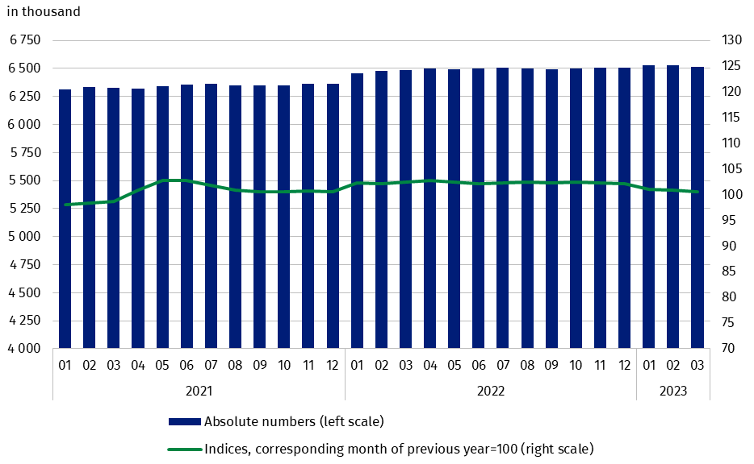
Chart 1. Average paid employment in the enterprise sector
In March 2023 average monthly gross wage and salary in the enterprise sector increased compared to February 2023 by 6.3%. In March 2022 compared to February 2022 higher increase was in wages dynamics, i.e. by 7.2%.
Average monthly gross wages and salaries in the enterprise sector includes the base salary and additional salary components, incl. bonuses, awards, remuneration for overtime and retirement severance pays
The increase in average monthly wages and salaries in March 2023 compared to February 2023 was caused by the continuation of payments of, among others, annual bonuses and awards, jubilee awards, quarterly bonuses, pay rises, overtime pays, and retirement severance pays (which beside the base salary are also included as components of wages and salaries). The highest increase in average monthly gross wages and salaries was noted in the section “Professional, scientific and technical activities” (by 11.3%), where salaries amounted to 10789.93 PLN (a month before 9698.14 PLN) and “Information and communication” (by 11.0%), where salaries amounted to 13633.44 PLN (a month before 12284.79 PLN).
On an annual basis (March 2023 to March 2022), average monthly gross wage and salary increased by 12.6%. A year before (March 2022 to March 2021) the dynamics of growth in average wage was recorded at the level of 12.4%.

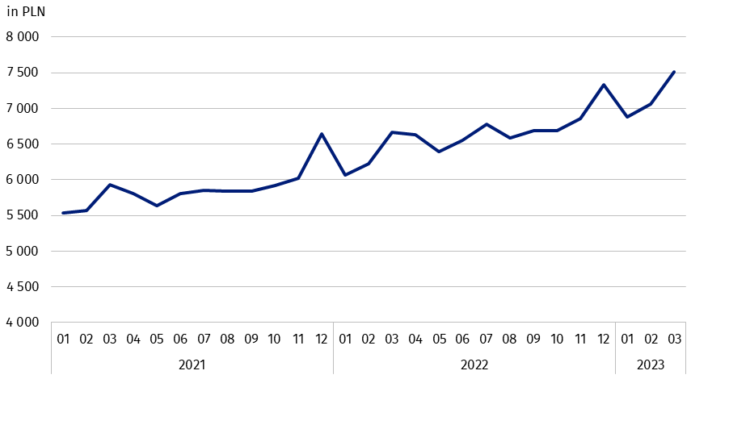
Chart 2. Average monthly gross wages and salaries in the enterprise sector
In the cumulative period of three months of 2023, average monthly gross wages and salaries in the enterprise sector, in relation to the same period of 2022 increased in all NACE Rev.2 sections by between 7.5% in section ”Construction” and 22.5% in section “Transportation and storage”, which resulted in total increase in the enterprise sector of 13.3%. The highest average gross salary in the enterprise sector in the cumulative period was noted in section “Information and communication” in the amount of 12636.07 PLN (an increase by 13.4% in regard to the same period of previous year), while the lowest in section “Accommodation and catering” at the level of 5245.16 PLN (despite an increase in relation to the situation a year ago by 14.7%).
In January 2023, the statutory minimum wage increased to 3490 PLN, i.e. by 15.9% compared to 2022, when it amounted to 3010 PLN (in 2022 an increase by 7.5% in regard to 2021), which also affected changes in average monthly gross wages and salaries in the enterprise sector

Methodological notes
The enterprise sector concerns units with the number of employed persons 10 or more people and conducting economic activity within the scope of the following areas: forestry and logging; marine fishing; mining and quarrying; manufacturing; electricity, gas, steam and air conditioning supply; water supply; sewerage, waste management and remediation activities; construction; wholesale and retail trade; repair of motor vehicles and motorcycles; transportation and storage; accommodation and food service activities; information and communication; real estate activities; legal and accounting activities; activities of head offices; management consultancy activities; architectural and engineering activities; technical testing and analysis; advertising and market research; other professional, scientific and technical activities; administrative and support service activities; arts, entertainment and recreation; repair of computers and personal and household goods; other personal service activities.
Data source is “Report on economic activity” (DG-1). Within the scope of this survey, for the entities with the number of employed persons 50 and more people it is a census survey, while for the entities with the number of employed persons from 10 to 49 people it is a sample one.
Labour market data on survey report DG-1 do not include persons employed under a mandate contract and contract for specified work – the detailed scope of exclusions along with methods of calculating labour market variables can be found in the explanations of the DG-1 report.
Due to the short period in which the units provide data as part of the survey on the DG-1 form, the presented results are preliminary. In the absence of complete records as at the date of preparation of the survey, it is allowed to include estimated data, and in the event of the need to correct data disclosed in previous periods, changes are included only in cumulative data.

Prepared by:  Labour Market Department  Director Agnieszka Zgierska  Phone: (+48 22) 608 30 15 | Issued by:  The Spokesperson for the President  of Statistics Poland  Karolina Banaszek  Phone: (+48) 695 255 011
Press Office  Phone: (+48 22) 608 38 04  e-mail: obslugaprasowa@stat.gov.pl |   stat.gov.pl/en/

@StatPoland

@GlownyUrzadStatystyczny

gus_stat

glownyurzadstatystycznygus

glownyurzadstatystyczny
Related information
Working. Employed. Wages and salaries. Cost of labour
Paid employment, wages and salaries in the national economy in 1st-3rd quarters of 2022
Structure of wages and salaries by occupation in October 2020
Methodological report Employed in the national economy
Methodological report Wages and salaries in the national economy
Data available in databases
Local Data Bank – Labour market
Macroeconomic Data Bank – Labour market
Terms used in official statistics
Enterprise sector in the labour market and wages and salaries statistics
Average paid employment
Wages and salaries to calculate average monthly wages and salaries

Average paid employment after converting the dimensions of part-time employees into full-time equivalents.
Activities included in the enterprise sector are listed on the page 4.
Excluding “Scientific research and development” (Division 72) and “Veterinary activities” (Division 75);
Methodological report Monthly activity report of enterprises: https://stat.gov.pl/en/topics/economic-activities-finances/activity-of-enterprises-activity-of-companies/methodological-report-monthly-activity-report-of-enterprises,17,1.html.
DG-1 report in English is available in Methodological report Monthly activity report of enterprises: https://stat.gov.pl/en/topics/economic-activities-finances/activity-of-enterprises-activity-of-companies/methodological-report-monthly-activity-report-of-enterprises,17,1.html.

