Employed persons in the national economy in Poland in December 2025
On the last day of December 2025, the population of employed persons in the national economy was 15 125.0 thousand, i.e. 0.3% fewer than in December 2024. Compared with the previous month, their number increased by 0.2%.
15.1 million
number of employed persons in the national economy as at
31 December 2025
The data refer to employed persons in the national economy, living in Poland or abroad. Each employed person is identified once – in the main job.
Number of employed persons in the national economy
Among all employed persons in the national economy, men constitute the majority. At the end of December 2025, their share was 52.6%, which was 0.1 percentage points (pp) lower than a year earlier and the same as a month earlier.
On the last day of December 2025, men accounted for 52.6% of the total number of employed persons in the national economy
Compared with December 2024, the number of employed women decreased by 0.1%, while the number of employed men by 0.5%. Compared with the end of November 2025, the numbers of employed women and men increased by 0.2%.
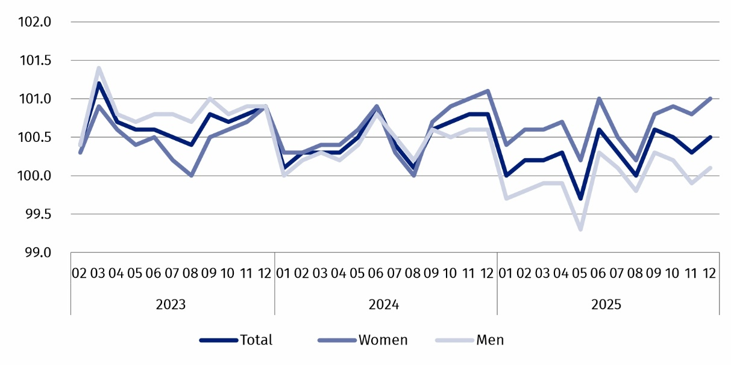
Chart 1. Indices of the number of employed persons in the national economy
(01 2023 = 100)

Mean age and median age
At the end of December 2025, the mean age of employed persons (calculated in years) was 43.1 (42.8 at the end of December 2024, 43.1 at the end of November 2025). The median age of employed persons also increased during the year. On the last day of December 2025, it was 43.0 years, a year higher than at the end of December 2024.
PKD 2007/NACE Rev. 2 sections
The structure of employed persons in the national economy by PKD 2007/NACE Rev. 2 section does not change significantly from month to month. As at the end of December 2025, the most persons were employed in the Manufacturing section – 2 726.8 thousand, which accounted for 18.0% of the total number of employed persons in the national economy. This share was 0.3 pp lower than at the end of December 2024 and the same as on the last day of November 2025. At the end of December 2025, the second section in terms of the number of employed persons – Trade; repair of motor vehicles∆ concentrated 14.2% of the total number of employed persons – 0.3 pp fewer than a year earlier and the same as at the end of November 2025.
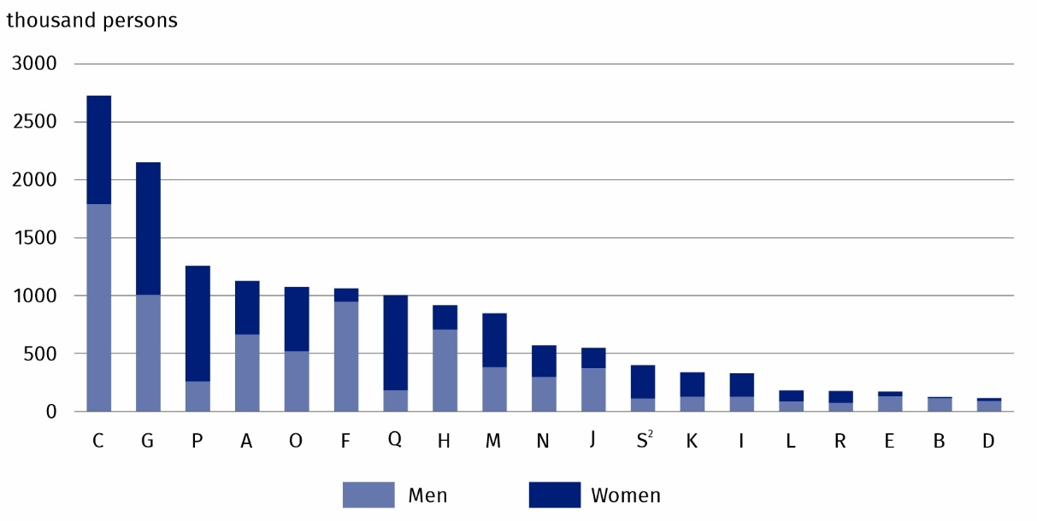
Chart 2. Employed persons in the national economy by sex and PKD 2007/NACE Rev. 2 section in December 2025
As at the end of the month
Among seven PKD 2007/NACE Rev. 2 sections, the largest decrease in the number of employed persons relative to 31 December 2024 was in the Agriculture, forestry and fishing section – by 4.4%. Decreases in the number of employed persons were also recorded in the Trade; repair of motor vehicles∆ and Manufacturing sections – by 2.3% and 1.7%, respectively. Among the PKD 2007/NACE Rev. 2 sections³ , the largest increase in the number of employed persons compared with December 2024 occurred in sections: Public administration and defence; compulsory social security – by 2.5%, Education – by 2.1% and Human health and social work activities – by 1.5%. The number of employed persons in the Construction section also increased – by 0.3%.
At the end of December 2025 – similarly to previous months – the Human health and social work activities and Education sections were most feminised, while the greatest share of men was in the Mining and quarrying and Construction sections

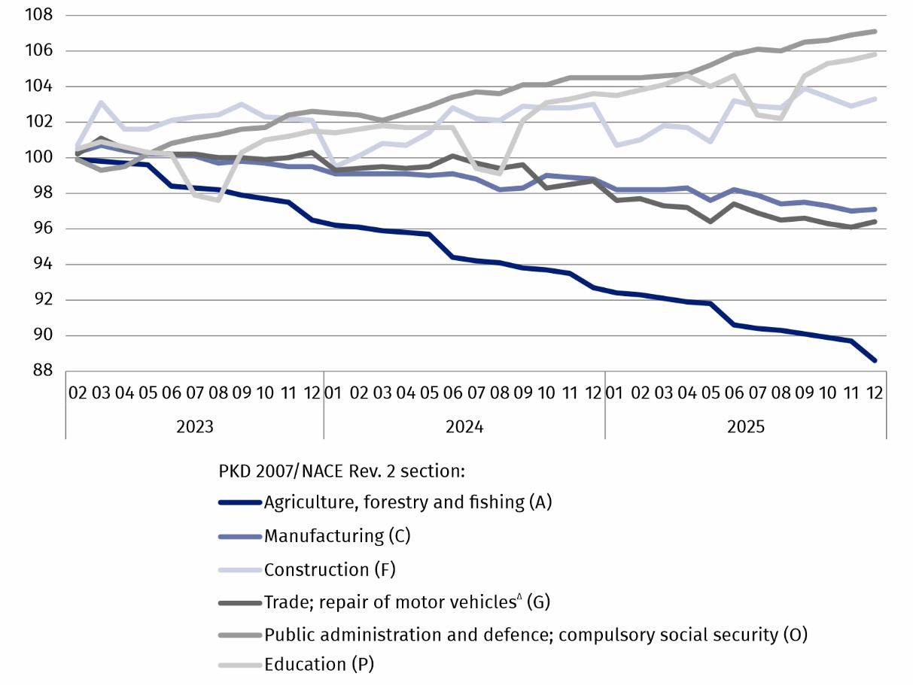
Chart 3. Indices of the number of employed persons in the national economy by selected PKD 2007/NACE Rev. 2 sections
(01 2023 = 100)
Employment status
On the last day of December 2025 – as in earlier months – the shares of men and women in the population of employees were similar
The dominant group of employed persons were employees – there were 11 919.3 thousand of them. At the end of December 2025, they accounted for 78.8% of the total number of employed persons in the national economy. This share was the same as in December 2024, but 0.1 pp lower than on the last day of November 2025. The next largest subpopulation of employed persons in the national economy consists of self-employed persons including contributing family workers. As at 31 December 2025, they accounted for 21.0% of the total number of employed persons in the national economy. This share was the same as at the end of December 2024, but 0.1 pp higher than on the last day of November 2025.

In this publication symbols and abbreviated names of PKD 2007/NACE Rev. 2 sections were used marking abbreviations with a ‘Δ’ symbol. The full names can be found in the list of PKD 2007/NACE Rev. 2 sections below.
Full names of PKD 2007/NACE Rev. 2 sections:
A – Agriculture, forestry and fishing;
B – Mining and quarrying;
C – Manufacturing;
D – Electricity, gas, steam and air conditioning supply;
E – Water supply; sewerage, waste management and remediation activities;
F – Construction;
G – Wholesale and retail trade; repair of motor vehicles and motorcycles;
H – Transportation and storage;
I – Accommodation and food service activities;
J – Information and communication;
K – Financial and insurance activities;
L – Real estate activities;
M – Professional, scientific and technical activities;
N – Administrative and support service activities;
O – Public administration and defence; compulsory social security;
P – Education;
Q – Human health and social work activities;
R – Arts, entertainment and recreation;
S – Other service activities.
The data for the Other service activities (S) section also cover employed persons in the Activities of households as employers; undifferentiated goods- and services-producing activities of households for own use (T) and Activities of extraterritorial organisations and bodies (U) sections.
In the case of quoting Statistics Poland data, please provide information: ‘Source of data: Statistics Poland’, and in the case of publishing calculations made on data published by Statistics Poland, please provide information: ‘Own work based on Statistics Poland data.’
Prepared by:  Statistical Office in Bydgoszcz  Acting Director Katarzyna Klamrowska  Phone: (+48 52) 366 93 90 | Issued by:  Press Office  Mobile phone: (+48) 695 255 032  Landline phones: (+48 22) 608 38 04, (+48 22) 449 41 45,  (+48 22) 608 30 09  e-mail: obslugaprasowa@stat.gov.pl

stat.gov.pl/en/

@StatPoland

@GlownyUrzadStatystyczny

@gus_stat

@GłównyUrządStatystycznyGUS

@Glówny Urząd Statystyczny
Related information
Methodological report Employment in the national economy
Data available in databases
Knowledge Databases → Database → Society → Labour Market
Local Data Bank → Labour Market
Strateg → Statistics by theme → Labour Market
Platform SDG – national indicators
Geostatistics Portal
Terms used in official statistics
Employed persons in the national economy

Detailed data on employed persons in the national economy can be found in the 29 tables attached to this publication.
The data for the Other service activities (S) section also cover employed persons in the Activities of households as employers; undifferentiated goods- and services-producing activities of households for own use (T) and Activities of extraterritorial organisations and bodies (U) sections.
PKD 2007/NACE Rev. 2 sections, in which the number of the employed persons has exceeded one million.

