
Statistical Office in Poznan



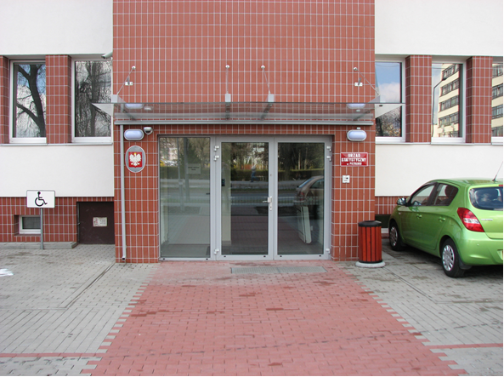
Statistical Office in Poznan is located by
Wojska Polskiego 27/29 Street.
There is a parking place for a disabled person available.
The building is located nearby the crossroads of Wojska Polskiego and Wołyńska streets.
You can get here in trams number 9 and 11 as well as buses number 160, 164 and 182. You have to get off at the Uniwersytet Przyrodniczy bus stop.
The office building is accessible to people with mobility difficulties.
There is an office on the ground floor.
You can leave there the documents.

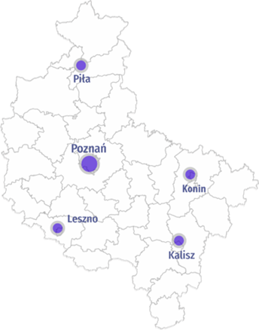
Statistical Office in Poznan has four Branches in:
Kalisz,
Konin,
Leszno,
Piła.
You can find all the information about Branches in
Contact details.
At the Statistical Office and its Branches you can find a place where you will have the access to statistical data.
This place is called Informatorium.
You can also register your company in REGON or make an update.

